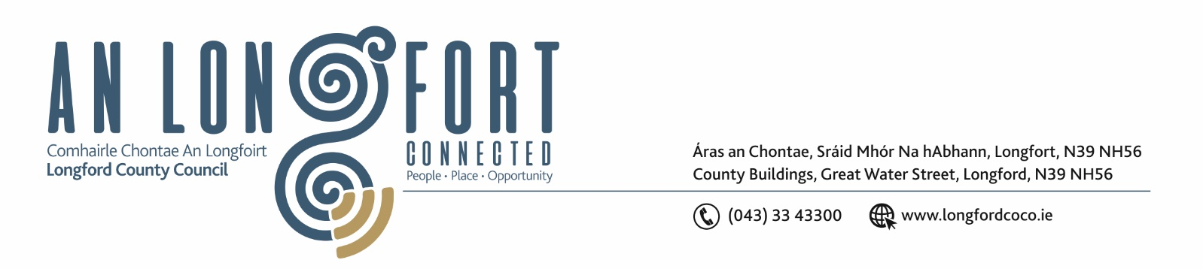

5u Iuil 2018.

Chuig: Gach Ball don Chomhairle.

A Chomhairleoir,

Iarrtar ort bheith i láthair ag Cruinniú Míosuil Chomhairle Chontae Longfoirt a tionólfar i Seomra na Comhairle, Aras an Chontae, Longfoirt ar an Chéadaoin, 11u Iuil 2018 ag 4.00 p.m chun gnó a dhéanamh d’réir an Chláir thíos.

You are requested to attend the Monthly Meeting of Longford County Council to be held in the Council Chamber, Aras an Chontae, Great Water Street, Longford, on Wednesday, 11th July 2018 at 4.00 p.m. to transact business, as set out on the Agenda hereunder.

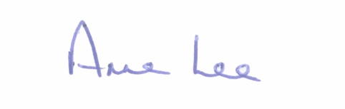
Mise le meas,

_______________
Anne Lee,
Meetings Administrator.

C L A R

Prayer before Meeting.

- Confirmation of Minutes of the following Meetings of Longford County Council –
- Monthly Meeting held on the 13th June 2018.
- Annual Meeting held on the 21st June 2018.
- copies enclosed.

2. Matters arising from Minutes.

3. To note Chief Executive Orders. (Summary herewith)

4. To note Monthly Management Report - to follow.

5. To note adopted Minutes of Corporate Policy Group Meeting held on
9th May 2018 - (copy enclosed).

6. Housing, Infrastructure, Environment & Emergency Services.

- Consideration of Draft Policy for the use of Vehicle Activated Signs - enclosed.
Referred from Infrastructure and Environment Strategic Policy Committee.

(b) Consideration of Civil Defence Application Form - enclosed, including pricing structure of -
- €150 - Half Day Event (3.5 hours)
- €300 - Full Day Event
- No Charge -Charity Event.

Referred from Infrastructure and Environment Strategic Policy Committee.

(c) Notice of Motion, submitted by Councillor Mae Sexton.

“That this County Council relocates the Salt & Gritting Barn on the Park Road to a more convenient location on the edge of town e.g. N4 / N5 /N63.”

7. Finance & Information Systems.

(a) To note Public Liability Claims received during June 2018 – report enclosed.

8. Economic and Community Development, Planning, Human Resources & Corporate Services, Cultural & Recreational Services.

- To note Planning Applications received since June meeting of the Council.

- National Libraries Strategy - “Our Public Libraries 2022 – Inspiring, Connecting and Empowering Communities” – enclosed.
Briefing by Mary Carleton-Reynolds, County Librarian.

- Notice of Motion submitted by Councillor Gerry Warnock.
“I am proposing that Longford County Council invite representatives from Failte Ireland’s “Ireland’s Hidden Heartlands” Team to address the September meeting of LCC regarding Longford’s place within the new brand. It would be highly beneficial for the Elected Members, the Executive and Administration of LCC to get the opportunity to have a public discussion with the State Agency to explore the many opportunities that this new brand will undoubtedly present for the local authority, the local communities and local enterprise in our efforts to develop Longford as a significant tourism destination.”

9. General

- Notices of Motions submitted by Councillors, as listed hereunder –

Councillor Michael Carrigy.

“I call on Longford County Council to support the IFA concerns and proposals about the treatment of farm assets in relation to the Fair Deal Scheme.”

- Correspondence – circulated.

- Correspondence dated 15th June 2018 received from Dr. John McHugh regarding the Presidency of Ireland.

- Correspondence dated 5th June 2018 received from the Office of the Minister for Finance and Public Expenditure and Reform regarding legislation in relation to private equity funds.

10. Votes of sympathy.



